Johnson and Daltrey
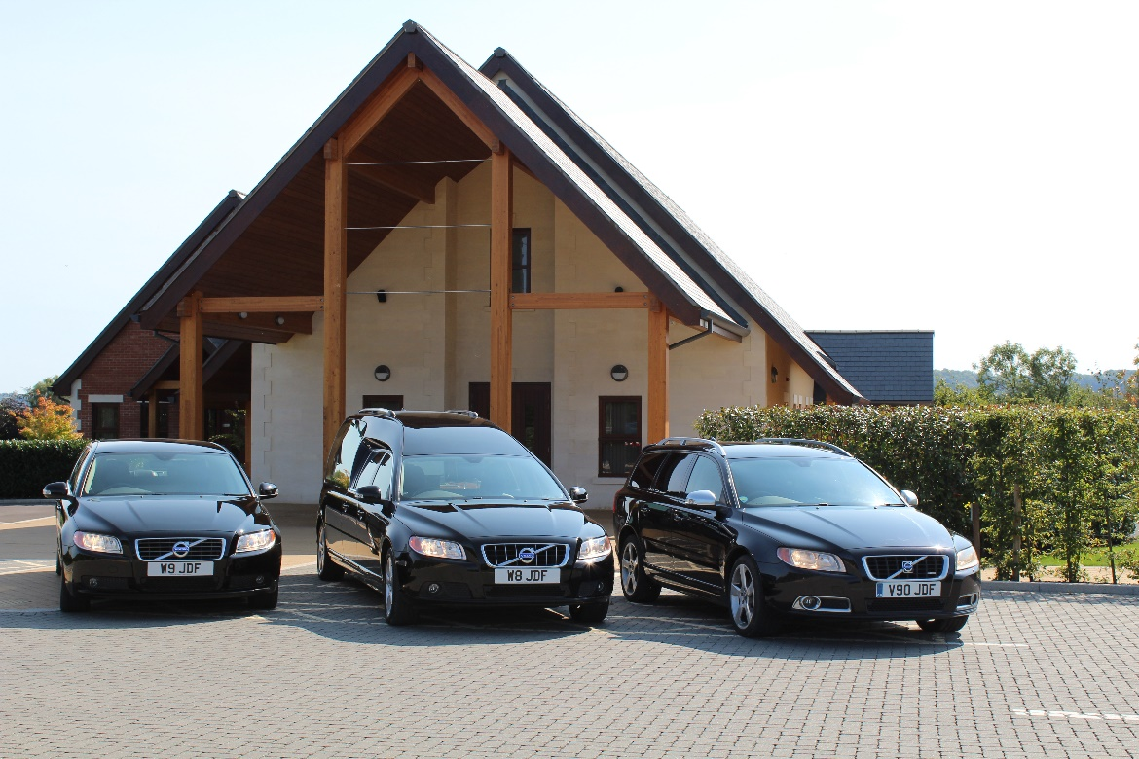

Independent Funeral Directors

Our History

How Johnson & Daltrey Started
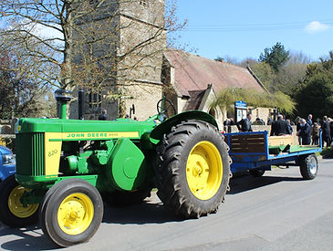
Working in a funeral directors from just 14 years of age, Ricki Johnson, the Managing Director and owner of the business, gained an invaluable amount of experience within all areas of the industry.

He began his career working within the family funeral business in Devon. Six years later he moved to Swindon to become the foreman and transport manager for one of the largest funeral directors in Swindon at the time.

Ricki has cared for many clientele throughout his time in the industry, and prides himself in providing the highest level of care and attention to every family he works with.

He now owns and runs his own independent funeral directors consisting of 3 branches in Wiltshire, the result of a lifelong commitment to provide a traditional and personal service to families at their greatest times of need.

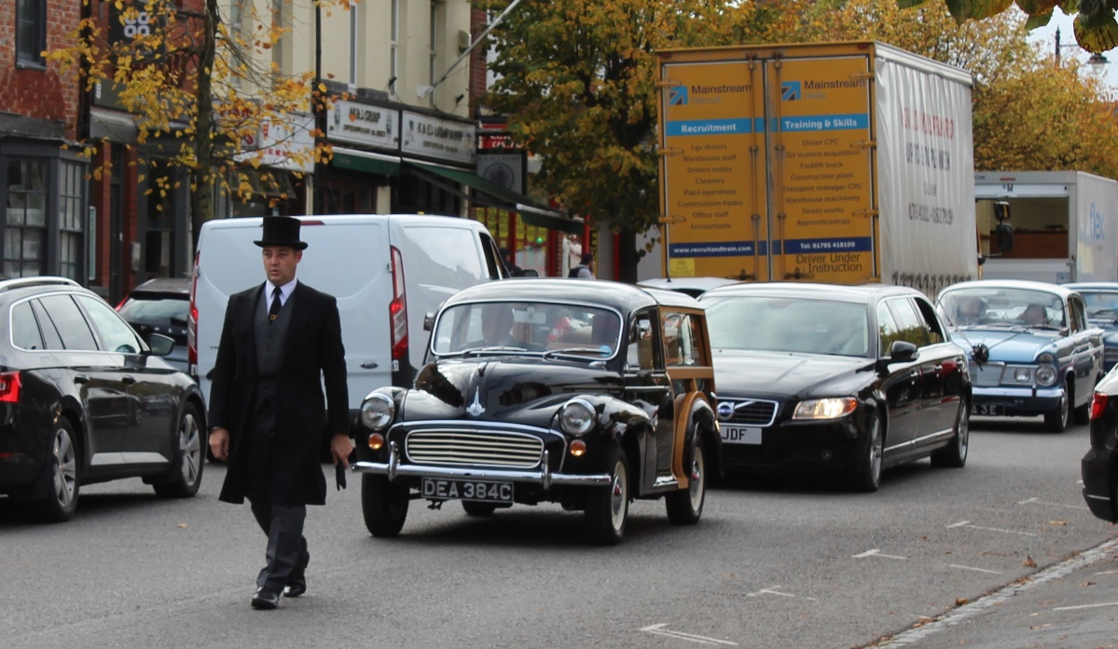

Our Funeral Homes

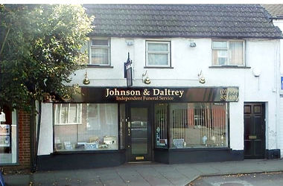
Our Royal Wootton Bassett Funeral Home

In July 2012, we opened our first branch at 112 High Street, Royal Wootton Bassett. Our Royal Wootton Bassett branch has a very homely feel, with its traditional décor and fireplace, along with a warm and welcoming colour scheme. As with all our branches, we have a private chapel of rest, allowing you to share valuable time with your loved ones, and say your goodbyes in a peaceful environment. Charlotte and Dana are situated at this branch alongside Ricki.

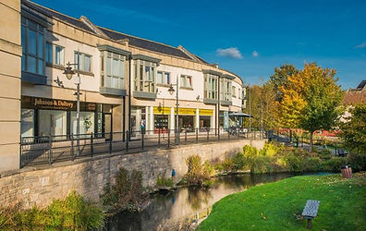
Our Calne Funeral Home
In August 2014, the opportunity arose to expand the business and serve the residents of Calne and surrounding areas. Situated at 1 Beach Terrace, overlooking the beautiful river Marden, our Calne branch is away from the main hustle and bustle of the town, and is the ideal place to come and make dignified arrangements. With the comfort of a private arrangement room and chapel of rest, along with a spacious and contemporary reception, a tranquil ambience is created to help you feel at ease.
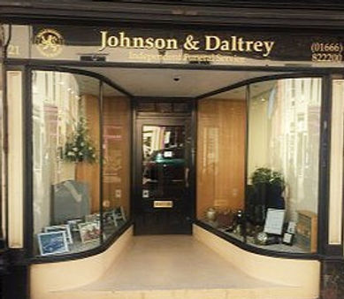

Our Malmesbury Funeral Home
In January 2017, we opened our third branch, situated on the quaint Malmesbury High Street. It is a fully functional funeral home, with all facilities on site to ensure the best care of your loved ones. In 2023 we partnered up with local funeral director Chris Brooks and rebranded to Brooks Independent Funeral Directors. The office proudly sits at 21 The High Street, Malmesbury.

Our People

Ricki
Ricki is the owner/director of Johnson and Daltrey. He has over 30 years experience in the funeral industry. His wealth of experience is invaluable to the business and the team. Ricki conducts funeral services and also works very hard behind the scenes attending to families and their needs. He also has a keen interest in vehicle repair and renovation and ensures our fleet is always maintained to the highest of standard.
​
Charlotte (Dip. FAA, Dip. FD)
Charlotte is a funeral arranger/director at Johnson and Daltrey. She began in the industry at the age of 18 and holds the National Association of Funeral Directors Diploma in Funeral Arranging & Administration and The National Association of Funeral Directors Diploma in Funeral Directing. Charlotte will assist you with arranging & conducting a funeral or memorial in any of our branches.
​
Dana
Born and bred in Royal Wootton Bassett Dana is our funeral arranger at Johnson and Daltrey. Having previously worked for the local crematorium, she joined us in 2021. Dana will assist you in all areas of arranging a funeral or memorial. Many of you may recognise Dana as her family used to run Woodland's which is now our Bassett branch!
​
Chris (Dip. FD)
In 2023 we partnered up with Malmesbury born and bred Chris Brooks and rebranded our Malmesbury branch to Brooks Independent Funeral Directors. He is an experienced and qualified funeral director with nearly two decades in the industry. He also holds his National Association of Funeral Directors Diploma.

The Pall Bearers
Our pall bearers are all very experienced local well-known gentleman that take extreme pride in their commitments to the families we look after.

What to do when somebody passes away

Here is a basic guide to what happens immediately after someone passes away. If you need further help or guidance, please don't hesitate to call us, we're here to support you during this difficult time.

At Home or Nursing Home
If your loved one passes away at home, the first step is to call the Doctors Surgery. Once a member of the team has attended and certified the passing you can then call us. We will attend and take your loved one back into our care. Where the passing occurs in a nursing home, the home staff will look after this process for you. It is helpful to inform the home we will be looking after the arrangements for the funeral in advance, so they know who to call at the time of need. We will then guide you through the rest of the process, ensuring that everything is handled with compassion and professionalism.

In Hospital
If your loved one has passed away in the hospital, the bereavement team will take care of the certification for you. You will need to confirm with them that we will be handling the funeral arrangements so that we can liaise directly with the hospital to bring your loved one into our care as soon as possible. We will be with you every step of the way throughout the planning process and beyond.

When the Coroner is Involved
When a passing occurs unexpectedly you will need to call 999 and explain what has happened. The Coroner's Team will attend and take your loved one back into the care of the coroner. You will need to inform the Coroner's Officer that we are looking after the funeral arrangements, so we can bring your loved one back into our care, once they have finished their investigations. We will be here to advise and support you as these investigations take place.

Registering a death in England
Here is a guide to registering the death.
The registration must take place in the district where the death took place. (Note: Swindon is a separate district to Wiltshire). You can attend a Registrar’s Office in another county. This is called 'Registration by Declaration' however this will usually cause a delay in getting the certificates you require and subsequently the funeral date. We are here to help and advise you every step of the way so please call if you need any guidance.

How to Register
Contact the Doctor’s Surgery and request the issue of the ‘Medical Cause of Death Certificate’ electronically to the Registrar so that you can make an appointment to register the passing. If a person passes in hospital, you will need to contact the Bereavement Team at the hospital rather than the Doctors Surgery.
Contact the Registrar to make an appointment to register. The passing must be registered in the district it occurred (if a person passes away in Great Western Hospital the passing must be registered in Swindon)

The registrar will ask for the following information:
- Date and place of the death The address of the person
- Their full names (including the maiden name of a married woman).
- Any former married names or other names by which the deceased was known can also be recorded.
- Date and Place of birth (the town or county is sufficient if the exact address is not known). Their occupation
- Details of their wife, husband or civil partner
- Whether they had any government pension or other benefits

It is helpful to take as many of the following as possible to your appointment to help the registrar gather this information:
- NHS card
- Birth certificate
- Driving licence
- Council tax bill
- Marriage or civil partnership certificate
- National Insurance number of the deceased and the number of a surviving spouse or civil partner.
- Passport
- Proof of address such as a utility bill or bank statement

The registrar will issue you with:

Registrar’s Certificate for Burial or Cremation.
We will require this document, also known as the ‘Green Form', to carry out the funeral.

Death Certificate
You can obtain more than one copy of this ‘Certified Copy of Entry’ and we would recommend doing so to enable you to deal with banks, building societies, etc., simultaneously.

Tell us Once Code
The ‘Tell us Once’ service is to report the passing to all government agencies in one go. The registrar will take you through this process.

When the Coroner is Involved
Where the Coroner is involved, there are several different courses of action that can take place. We can advise you on this along with the Coroners Officer looking after the case. It is not always clear what process will be followed until investigations are underway.

​
The details of local registrar offices are as follows:
Swindon: Civic Offices, Euclid St, Swindon, Wiltshire. SN1 2JH Tel: 01793 522738
Chippenham: 4 Timber St, Chippenham, Wiltshire. SN15 3BZ Tel: 0300 456 0100

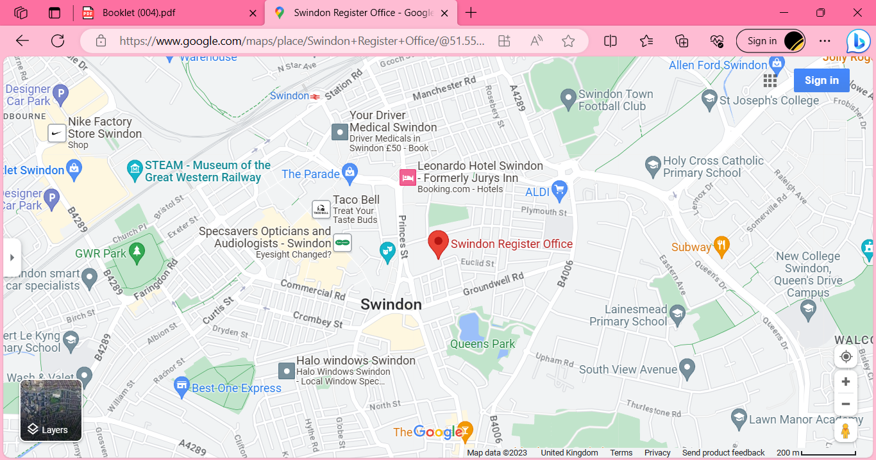
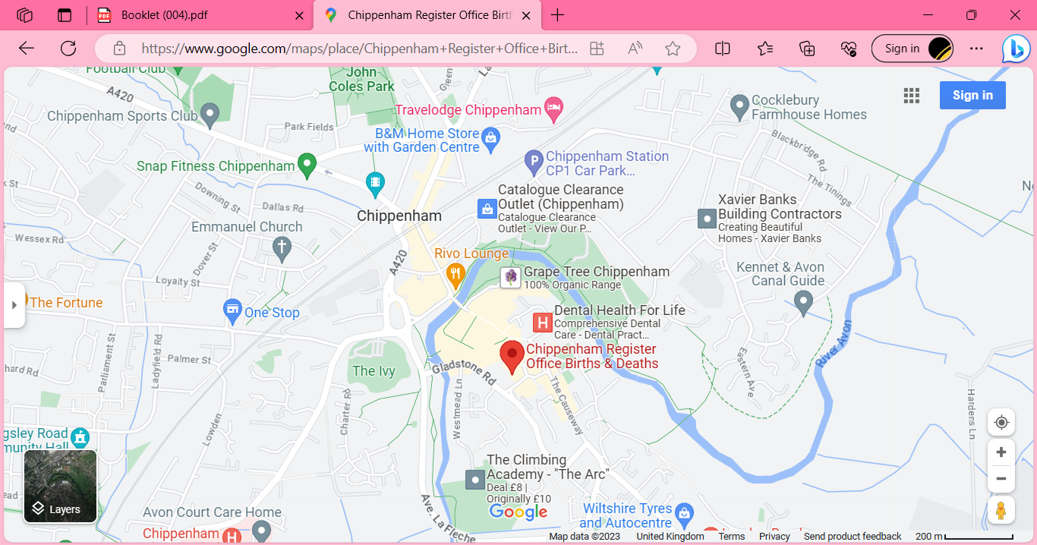

Arranging a funeral

Arranging a funeral. We offer a personalized service, tailored to your specific needs. We can meet you either at our office or in the comfort of your own home to plan the funeral, providing support and guidence throughout. We will liase with relevant third parties and put everything together for you. Here is a guide to some of the options we will cover when we meet.

Choice of Burial or Cremation
Options for burial include in the local Cemetery or your parish church if the churchyard is still open. There is also the option of a woodland burial, our local green burial ground is Westmill, located near shrivenham. Crematoria locally are North Wiltshire Crematorium, near Royal Wootton Bassett, Kingsdown Crematorium in Swindon, West Wiltshire Crematorium in Semington and Westerleigh Crematorium near Bristol.

Type of service
religious, non-religious or somewhere in the middle If the service is taking place in your parish church a minister from the parish will take the service. Where the service is taking place at the crematorium or other venue, we can also arrange for a celebrant to take a non-religious service for you. Whoever is taking the service will arrange to meet you and discuss the content.

Newspaper Notices
We can place a notice in a local and or national paper if you require. We will first provide a draft notice for you to approve before it goes to print.

Floral tributes
We can look after arranging floral tributes for you, again you can see some of the available options on our website, they can all be tailored to your wishes, including special colours and include specific flowers. We will have them delivered to us on the day of the funeral and will arrange for them to be taken back to your reception or donated to a local nursing home afterwards.

Printed order of service
A bespoke order of service can be a keepsake as well as a practical guide for the running order of the service at the funeral. Working with the person taking the service and using any pictures you supply we will put together a proof for you to approve before going to print. We will keep any left after the service for you, you may wish to send them to those who were unable to attend the service.

Our Coffins

All veneer and solid coffins also come in Sapele.
All coffins come with a lining; you can choose from: Pink, Blue, Cream or White.

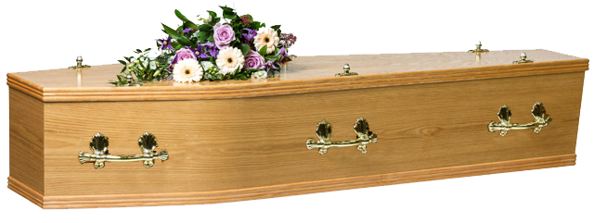
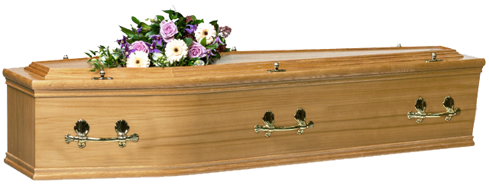

The Cherhill (oak veneer) The Cotswold (oak veneer)
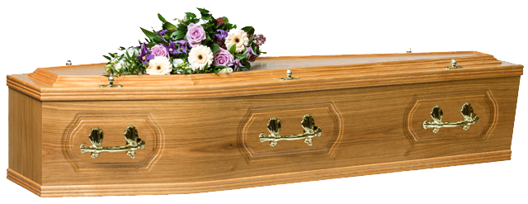
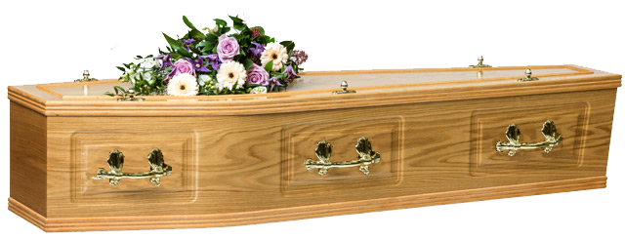

The Yatesbury (oak veneer) The Salisbury (oak veneer)

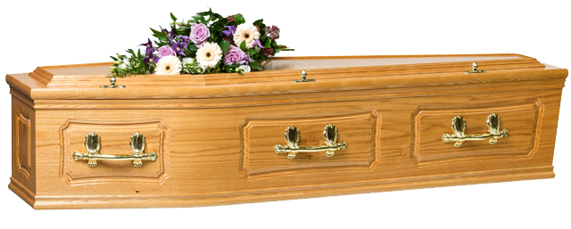
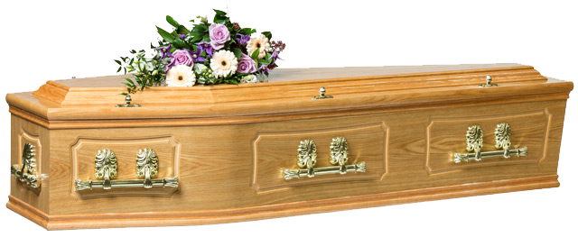

The Burford (oak veneer) The Avebury (Solid oak)

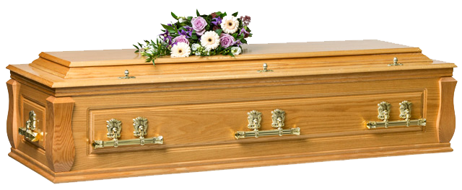
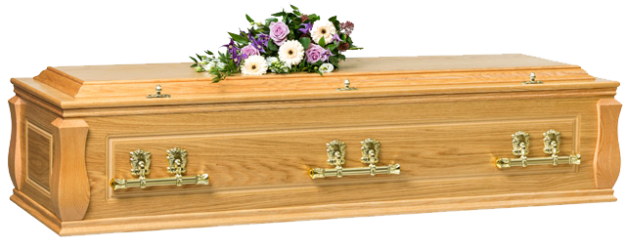

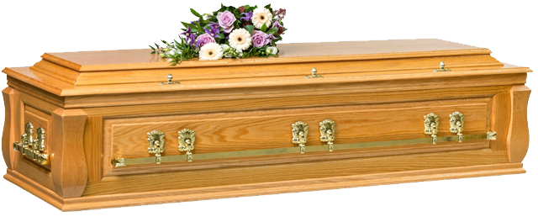
The Marlborough (oak veneer) The Somerford (Solid oak)


The Highgrove (Solid oak) The Round Willow
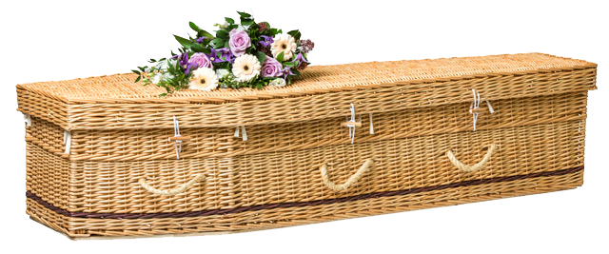
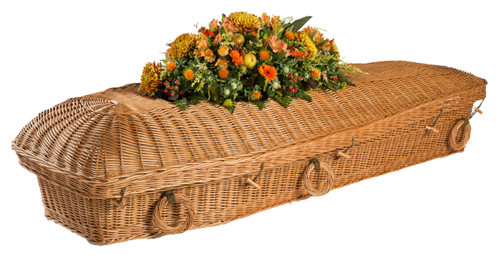


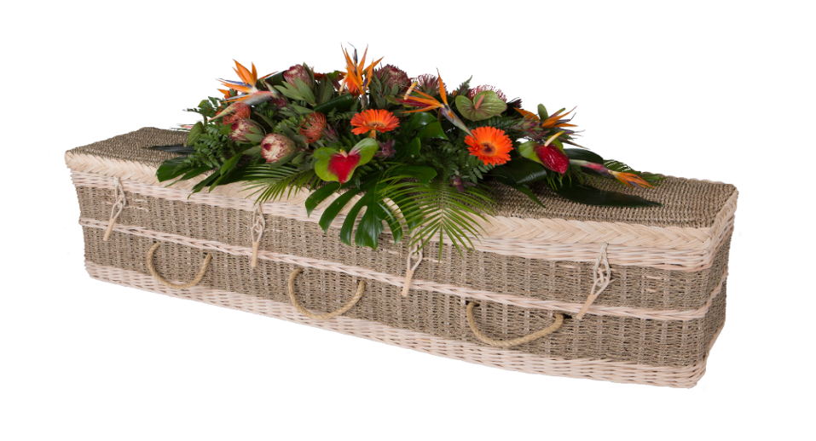
The Traditional Willow
The Willow Pod

The Seagrass Coffin The Picture Coffin (veneer/cardboard)

Direct Cremation
We offer a direct cremation service that provides a dignified and respectful farewell. We will handle every aspect of the cremation with the personal service we pride ourselves on, carried out with the utmost respect. Unlike national firms, you can rest assured that your loved one will remain in your local area Royal Wootton Bassett, Calne or Malmesbury until the cremation, and we can keep you informed of the date and where this will take place.

Masonry
If your loved one is buried, you may wish to place a memorial on the grave. There can be a number of rules and regulations depending on where the grave is, but we can guide you through these and help you to pick the most suitable stone.

Keepsakes & Ashes Jewellery
If you are looking for a keepsake we offer a wide variety of small urns, keepsakes and jewellery, including ashes into glass jewellery.

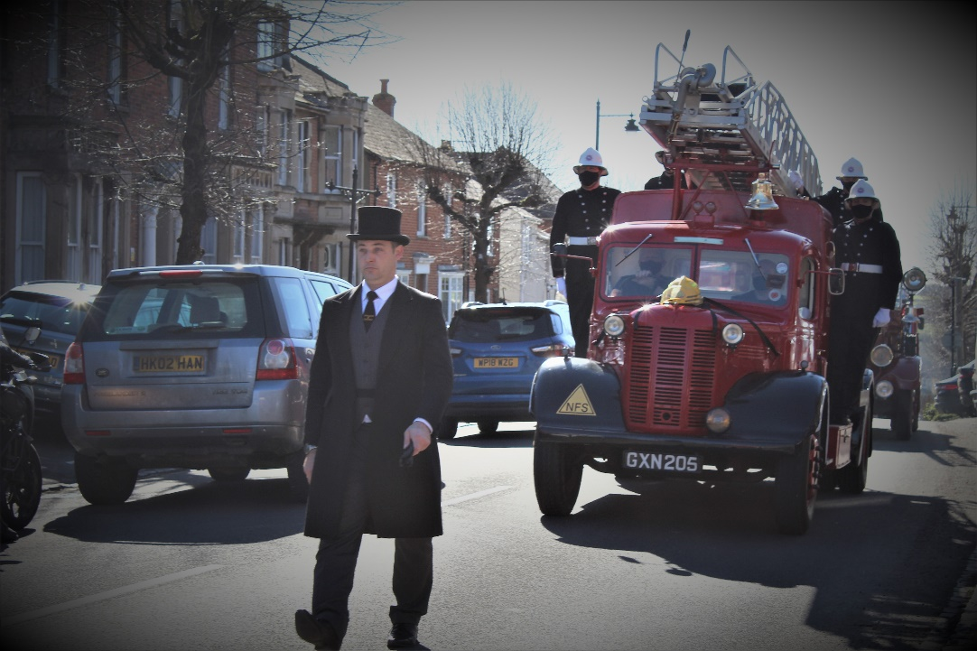

Contact
Our phones are answered 24 hours a day while our Office and Chapel of Rest are open weekdays 9.00am - 5.00pm, and by appointment outside of these hours.

Royal Wootton Bassett
Johnson and Daltrey Independent Funeral Directors
112 High Street
Royal Wootton Bassett
SN4 7AU
01793 851400

Calne
Johnson and Daltrey Independent Funeral Directors
1 Beach Terrace
Calne
SN11 0RD
01249 821200

Malmesbury
Brooks Independent Funeral Directors
21 High Street
Malmesbury
SN16 0RD
01666 822200

Email: info@jd-fs.co.uk
Web: www.johnsonanddaltrey.co.uk

